**https://medium.com/@reach2arunprakash/guvi-zen-class-javascript-warm-up-programming-problems-15973c74b87**

**1. Write a function called “addFive”.**

**Given a number, “addFive” returns 5 added to that number.**

**Input:**

**addFive(5);**

**addFive(0);**

**addFive(-5);**

**Output:**

**10**

**5**

**0**

**var num = 10;**

**function addFive(num) {**

**if(num%2===0) {**

**return num+5;**

**}**

**return num+5;**

**}**

**console.log(addFive(5));**

**console.log(addFive(0));**

**console.log(addFive(-5));**

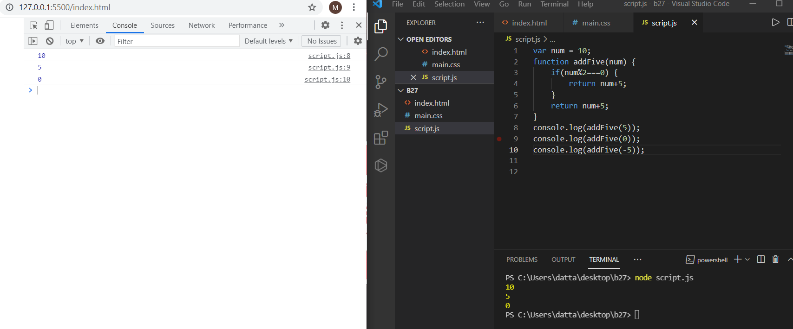

**2. Write a function called “getOpposite”.**

**Given a number, return its opposite**

**Input:**

**getOpposite(5);**

**getOpposite(0);**

**getOpposite(-5);**

**getOpposite(“5a”);**

**getOpposite(5.5);**

**Output:**

**-5**

**0**

**5**

**-1**

**-1**

**var num = 5;**

**function getOpposite(num) {**

**if(num===5) return -num;**

**else if(num===0) return num;**

**else if(num===-5) return -num;**

**else return -1;**

**}**

**console.log(getOpposite(5));**

**console.log(getOpposite(0));**

**console.log(getOpposite(-5));**

**console.log(getOpposite("5a"));**

**console.log(getOpposite(5.5));**

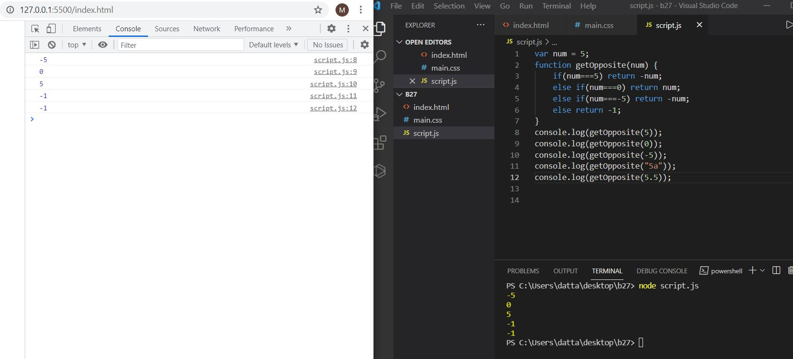

**3. Fill in your code that takes an number minutes and converts it to seconds.**

**var min = 5;**

**function toSeconds(min) {**

**secs= min*60;**

**return secs;**

**}**

**var secs = toSeconds(min);**

**console.log(secs);**

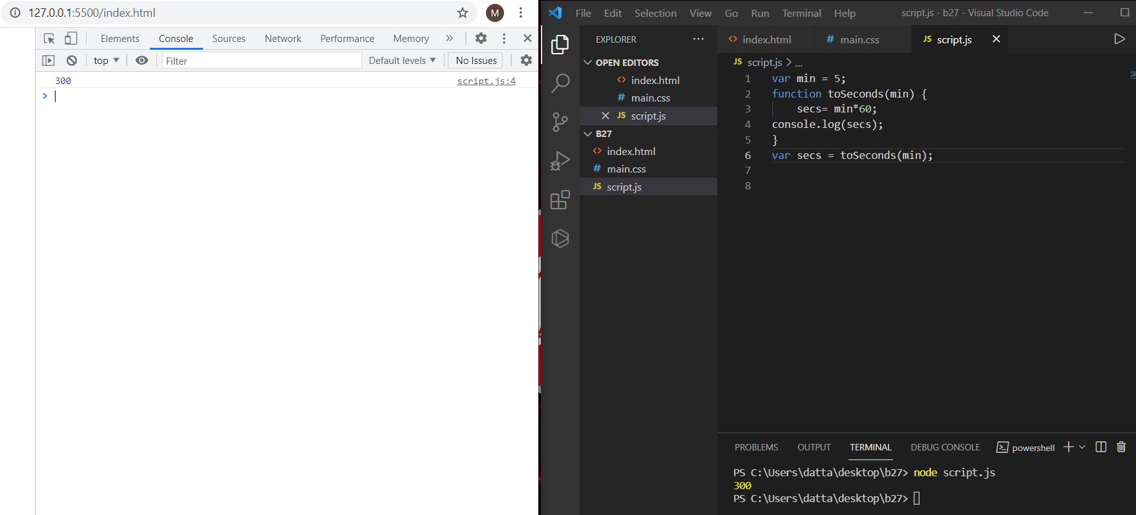

**4. Create a function that takes a string and returns it as an integer.**

**var mystr = "5";**

**function toInteger(mystr) {**

**myint = parseInt(mystr);**

**return myint;**

**}**

**var myint = toInteger(mystr);**

**console.log(myint);**

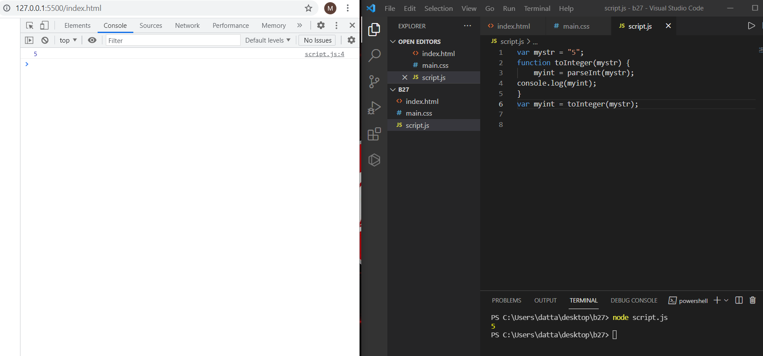

**5. Create a function that takes a number as an argument, increments the number by +1 and returns the result.**

**var myint = 0;**

**function nextNumber(myint) {**

**myNextint = myint+1;**

**return myNextint;**

**}**

**var myNextint = nextNumber(myint);**

**console.log(myNextint);**

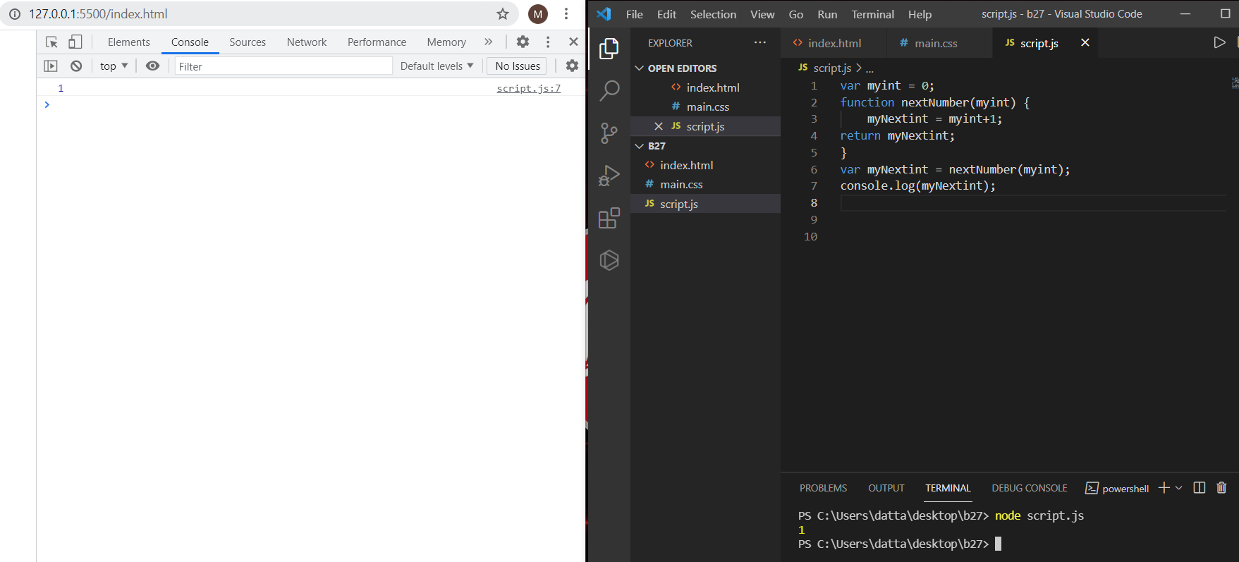

**6. Create a function that takes an array and returns the first element.**

**var arr = [1, 2, 3];**

**function getFirstElement(arr) {**

**for(let i=0;i<arr.length;i++){**

**if(arr[i]===arr[0]){**

**return arr[0];**

**}**

**}**

**}**

**var data = getFirstElement(arr);**

**console.log(data);**

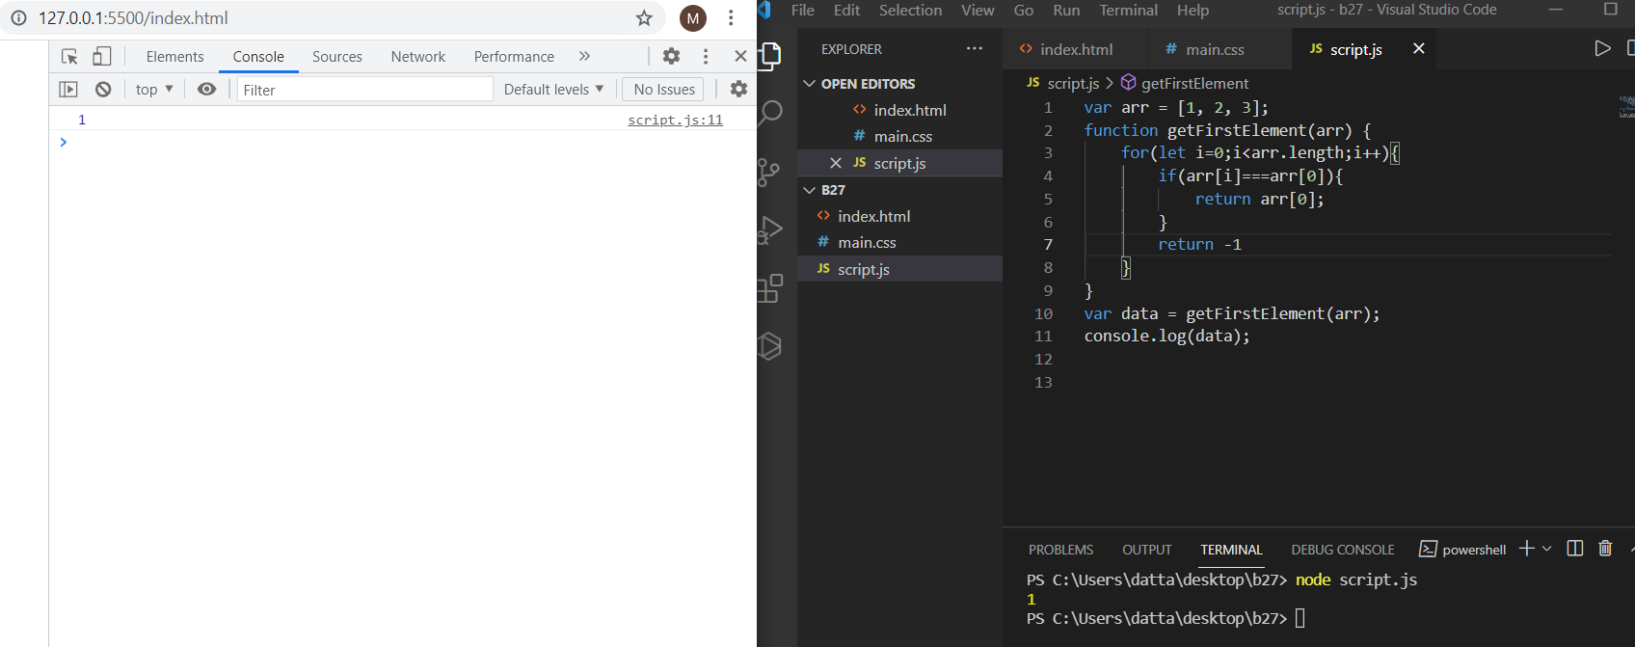

**7. Convert hours into seconds**

**write a function that converts hours into seconds.**

**var arr = [1, 2, 3];**

**function hourToSeconds(arr) {**

**for(let i=0;i<arr.length;i++){**

**console.log(arr[i]*3600);**

**}**

**}**

**hourToSeconds(arr);**

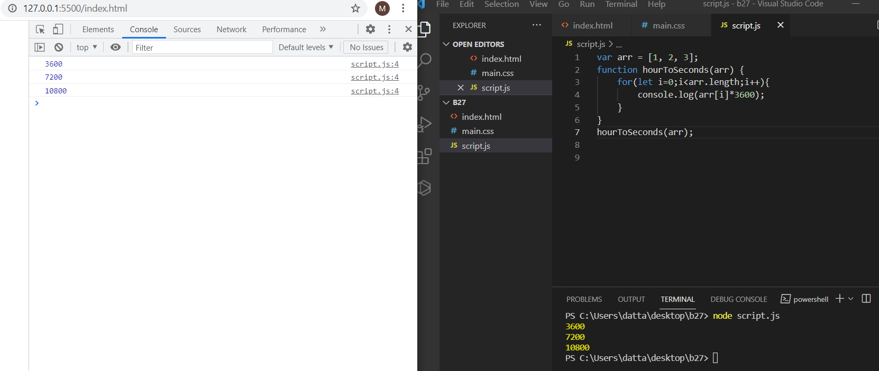

**8. Find the Perimeter of a Rectangle**

**Create a function that takes height and width and finds the perimeter of a rectangle.**

**function findPerimeter(num1,num2) {**

**peri = 2*(num1+num2);**

**return peri;**

**}**

**var peri = findPerimeter(10,7);**

**console.log(peri);**

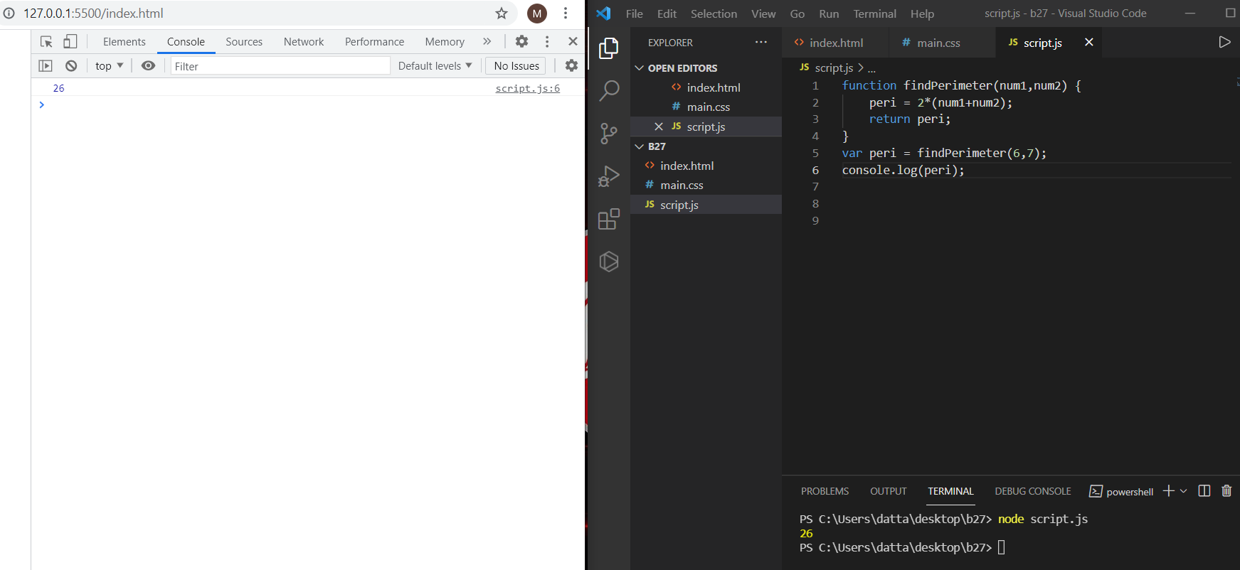

**9. Less Than 100?**

**Given two numbers, return true if the sum of both numbers is less than 100. Otherwise return false.**

**function lessThan100(num1,num2) {**

**res = num1 + num2;**

**if(res<100){**

**return true;**

**}**

**else{**

**return false;**

**}**

**}**

**var res = lessThan100(22,15);**

**console.log(res);**

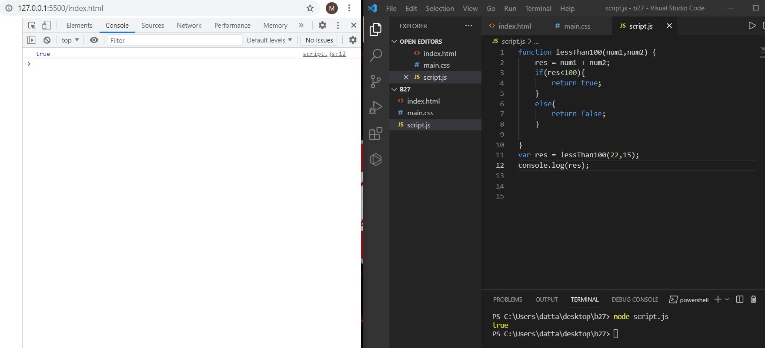

**10. There is a single operator in JavaScript, capable of providing the remainder of a division operation. Two numbers are passed as parameters. The first parameter divided by the second parameter will have a remainder, possibly zero. Return that value.**

**function remainder(num1,num2) {**

**res = num1%num2;**

**return res;**

**}**

**var res = remainder(1,3);**

**console.log(res);**

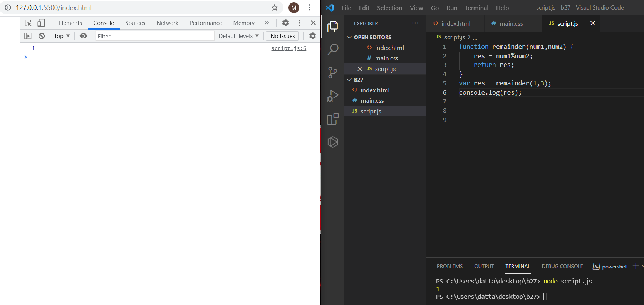

**11. Old macdonald had a farm:**

**MacDonald is asking you to tell him how many legs can be counted among all his animals. The farmer breeds three species:**

**turkey = 2 legs, horse = 4 legs, pigs = 4 legs**

**The farmer has counted his animals and he gives you a subtotal for each species. You have to implement a function that returns the total number of legs of all the animals.**

**function CountAnimals(tur,horse,pigs) {**

**legs = (tur*2)+(horse*4)+(pigs*4);**

**return legs;**

**}**

**var legs = CountAnimals(2,3,5);**

**console.log(legs);**

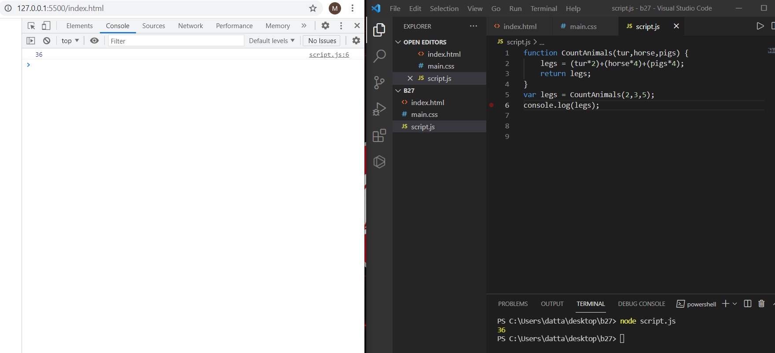

**12. Frames Per Second**

**Create a function that returns the number of frames shown in a given number of minutes for a certain FPS**

**function frames(num1,num2) {**

**fps = (num1*60)*(num2);**

**return fps;**

**}**

**var fps = frames(1,2);**

**console.log(fps);**

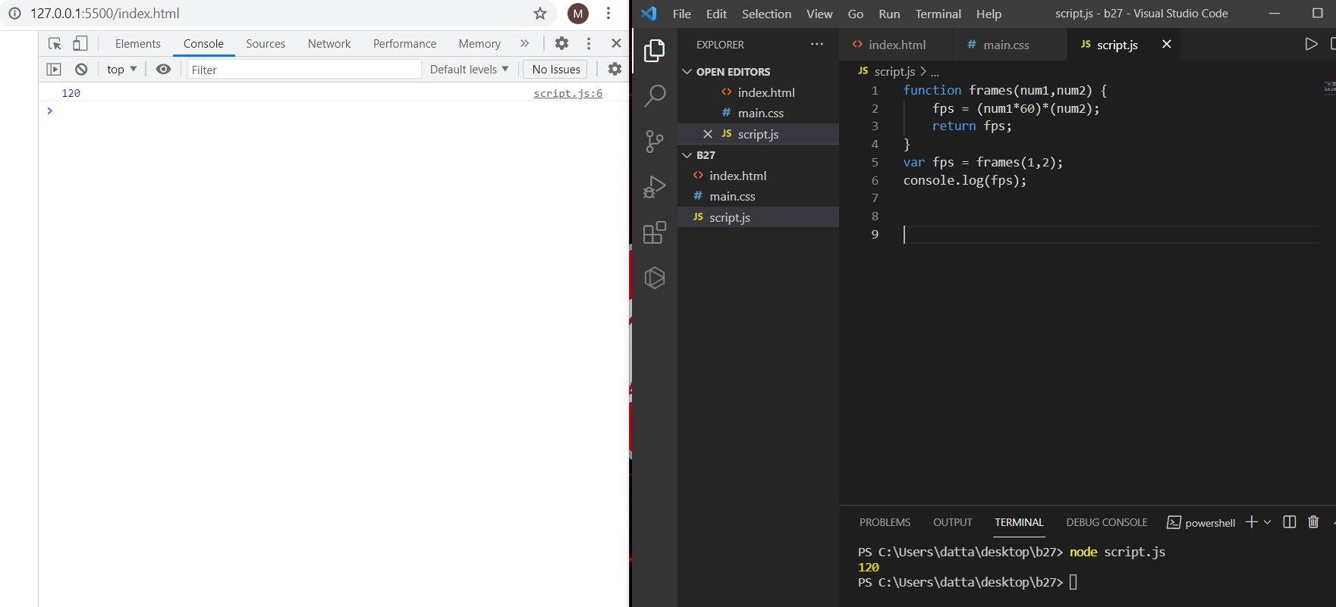

**13. Check if an Integer is Divisible By Five**

**Create a function that returns true if an integer is evenly divisible by 5, and false otherwise.**

**function divisibleByFive(num1) {**

**if(num1%5===0) return true;**

**else return false;**

**}**

**var divisible = divisibleByFive(5);**

**console.log(divisible);**

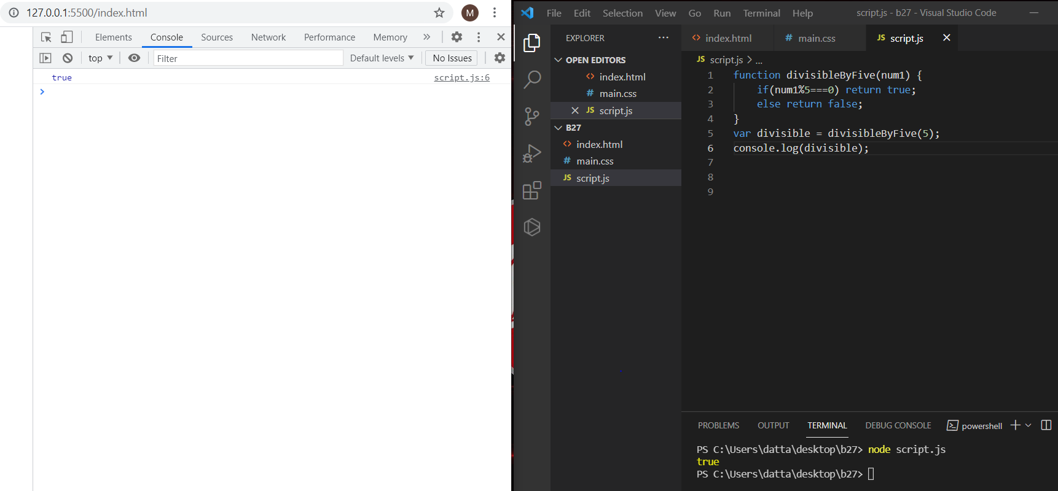

**14. Write a function called “isEven”.**

**Given a number, “isEven” returns whether it is even.**

**function isEven(num){**

**if(num%2===0) return true;**

**else if (num==="11h") return -1;**

**return false;**

**}**

**console.log(isEven(12));**

**console.log(isEven(0));**

**console.log(isEven(11));**

**console.log(isEven("11h"));**

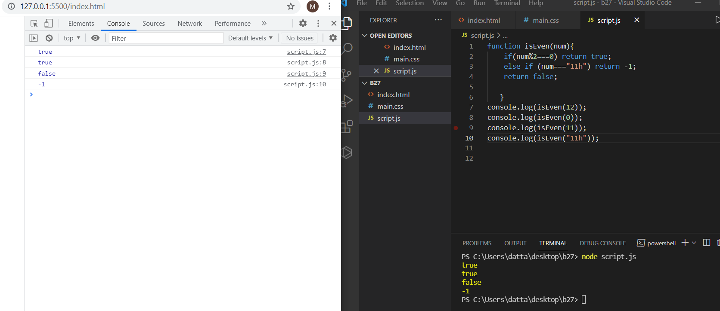

**15. Write a function called “areBothOdd”.**

**Given 2 numbers, “areBothOdd” returns whether or not both of the given numbers are odd.**

**Input:**

**areBothOdd(1, 3);**

**areBothOdd(1, 4);**

**areBothOdd(2, 3);**

**areBothOdd(0, 0);**

**Output:**

**true**

**false**

**false**

**false**

**function areBothOdd(num1, num2){**

**if(num1%2!==0 && num2%2!==0) return true;**

**return false;**

**}**

**console.log(areBothOdd(1, 3));**

**console.log(areBothOdd(1, 4));**

**console.log(areBothOdd(2, 3));**

**console.log(areBothOdd(0, 0));**

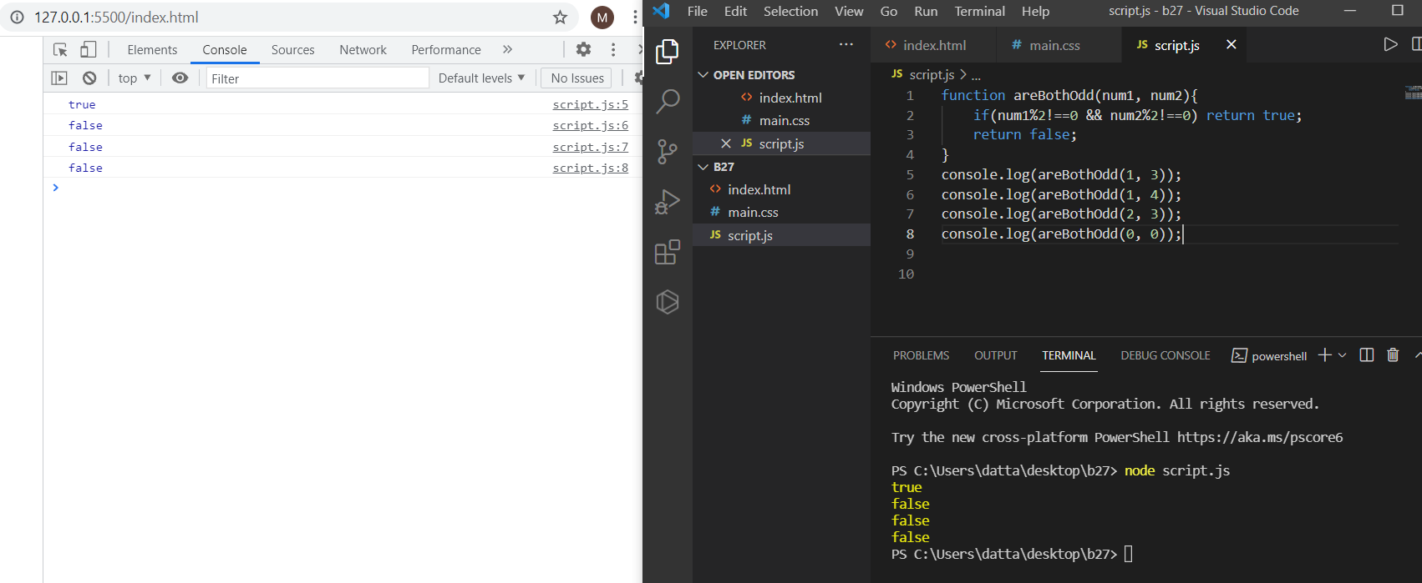

**16. Write a function called “getFullName”.**

**Given a first and a last name, “getFullName” returns a single string with the given first and last names separated by a single space.**

**function getFullName(firstName, lastName){**

**let concat = firstName+" "+lastName;**

**return concat;**

**}**

**console.log(getFullName("GUVI","GEEK"));**

**console.log(getFullName("GUVI",""));**

**console.log(getFullName("GEEK",""));**

**console.log(getFullName("\"\"",""));**

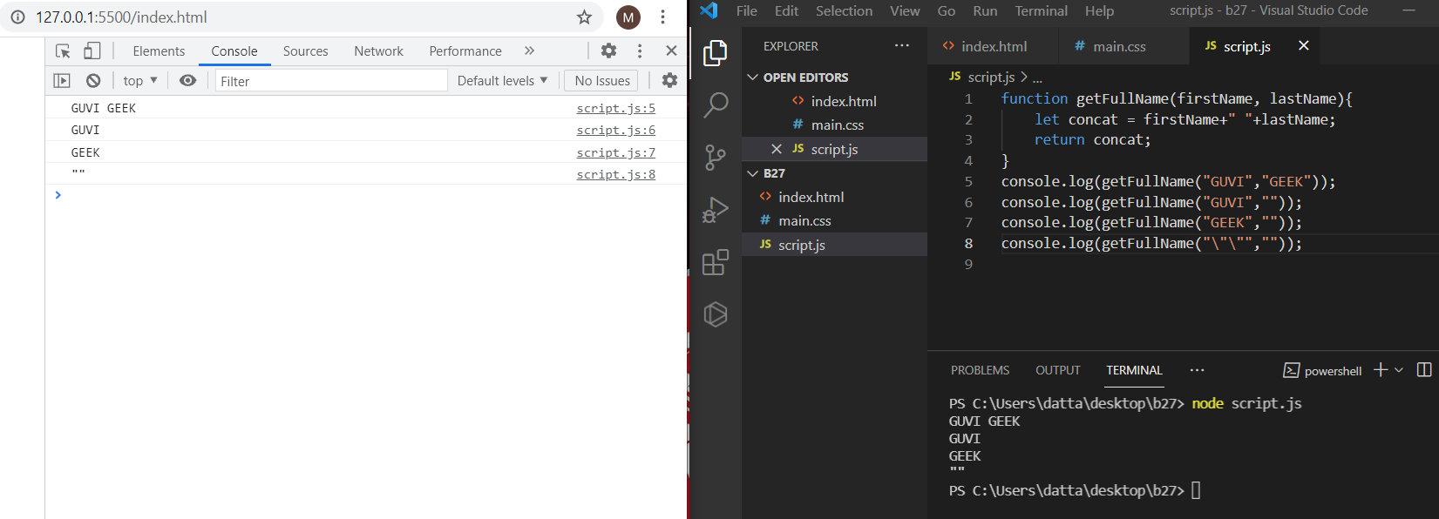

**17. Write a function called “getLengthOfWord”.**

**Given a word, “getLengthOfWord” returns the length of the given word.**

**Input:**

**getLengthOfWord(“GUVI”);**

**getLengthOfWord(“”);**

**getLengthOfWord();**

**getLengthOfWord(9);**

**Output:**

**4**

**0**

**-1**

**-1**

**function getLengthOfWord(word1){**

**if(word1 === "GUVI")**

**return word1.length;**

**else if (word1==="")**

**return 0;**

**else return -1;**

**}**

**console.log(getLengthOfWord("GUVI"));**

**console.log(getLengthOfWord(""));**

**console.log(getLengthOfWord());**

**console.log(getLengthOfWord(9));**

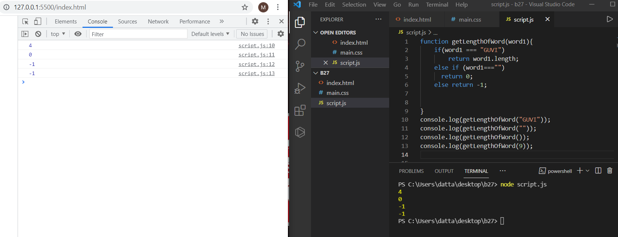

**18. Write a function called “isSameLength”.**

**Given two words, “isSameLength” returns whether the given words have the same length.**

**Input:**

**isSameLength(“GUVI”, “GEEK”);**

**Output:**

**true**

**function isSameLength(word1, word2){**

**let str = word1.length;**

**let len = word2.length;**

**if(str===len) return true;**

**else return false;**

**}**

**console.log(isSameLength("GUVI", "GEEK"));**

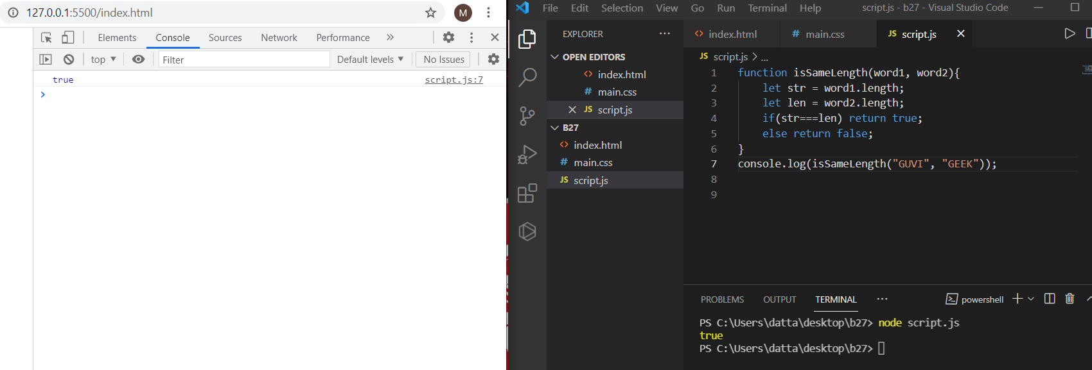

**19. Create a function to calculate the distance between two points defined by their x, y coordinates**

**console.log(getDistance(100, 100, 400, 300));**

**function getDistance(x1, y1, x2, y2)**

**{**

**let distance =Math.sqrt(Math.pow((x2-x1),2)+Math.pow((y2-y1),2));**

**return distance;**

**}**

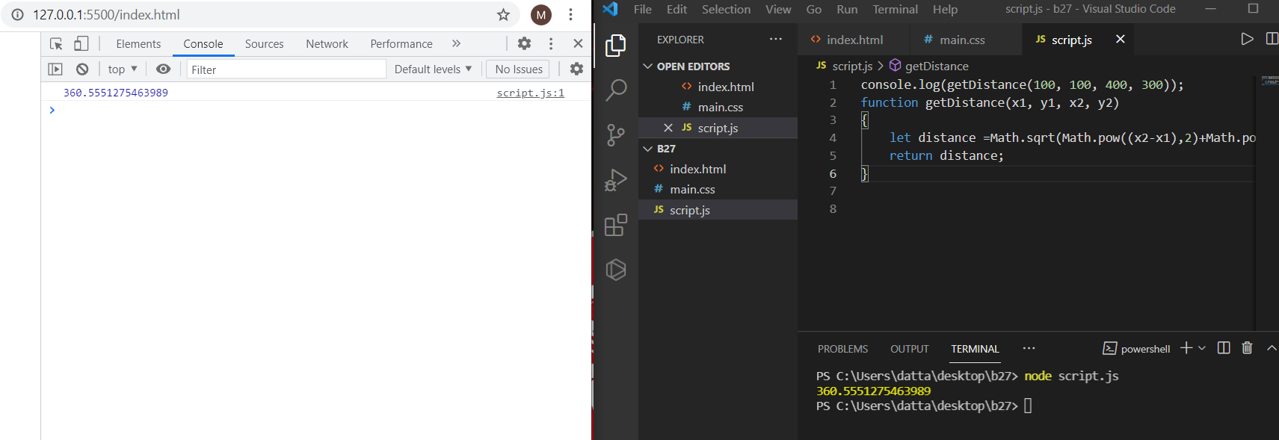

**20. Write a function called “getNthElement”.**

**Given an array and an integer, “getNthElement” returns the element at the given integer, within the given array. If the array has a length of 0, it should return ‘undefined’.**

**Input:**

**getNthElement([1, 3, 5], 1);**

**Output:3**

**var output = getNthElement([1, 3, 5], 1);**

**console.log(output);**

**function getNthElement(array, n) {**

**if(n===1) return array[n];**

**else return undefined;**

**}**

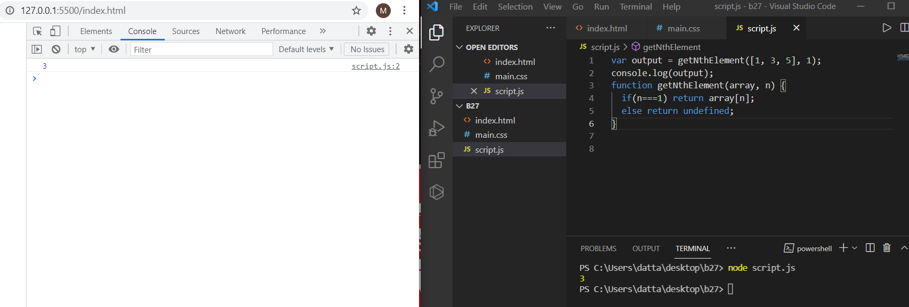

**21. Write a function called “getLastElement”.**

**Given an array, “getLastElement” returns the last element of the given array. If the given array has a length of 0, it should return ‘-1’.**

**Input:**

**getLastElement([1, 2, 3, 4]);**

**Output:**

**4**

**function getLastElement(array) {**

**var lastElement = array.length - 1;**

**if(lastElement===0) return -1;**

**return array[lastElement];**

**}**

**console.log(getLastElement([1, 2, 3, 4]));**

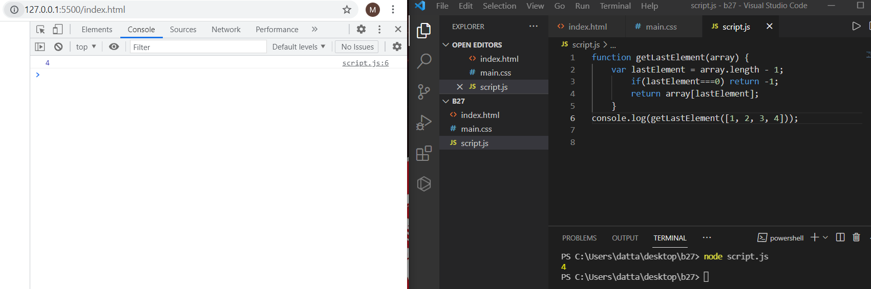

**22. Write a function called “getProperty”.**

**Given an object and a key, “getProperty” returns the value of the property at the given key. If there is no property at the given key, it should return undefined.**

**Input:**

**getProperty(obj,’mykey’);**

**getProperty(obj,’dummykey’);**

**Output:**

**value**

**NA**

**var obj = {**

**mykey: "value"**

**};**

**function getProperty(obj, key) {**

**for(let str in obj){**

**if(key===str) return obj[key];**

**return -1;**

**}**

**}**

**console.log(getProperty(obj,'mykey'));**

**console.log(getProperty(obj,'dummykey'));**

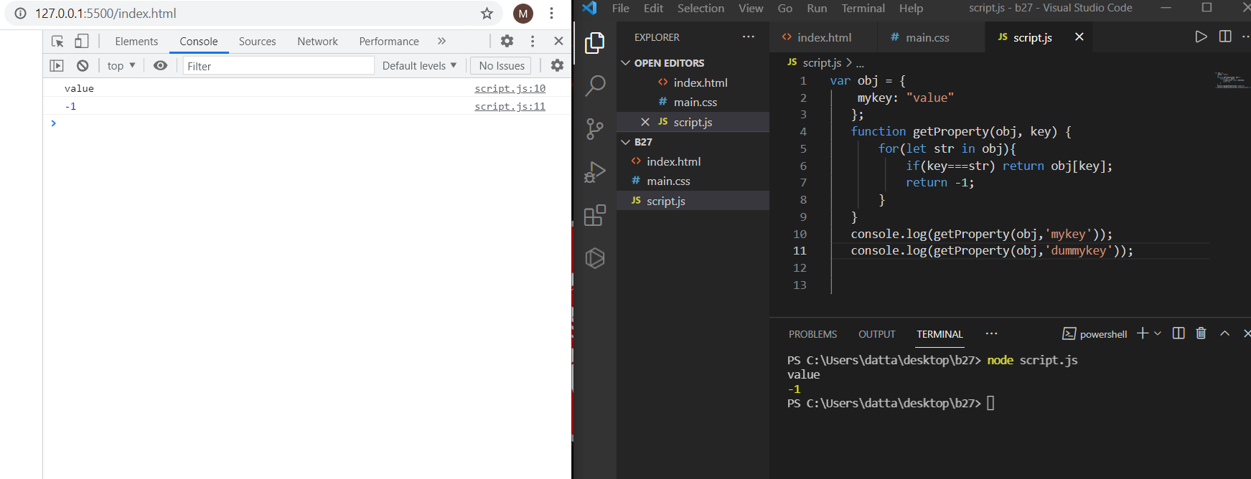

**23. Write a function called “removeProperty”.**

**Given an object and a key, “removeProperty” removes the given key from the given object.**

**Input:**

**removeProperty(obj, “name”);**

**Output:**

**undefined**

**var person = {**

**name:"Dattatreya",**

**age:23**

**};**

**function removeProperty(person, key){**

**delete person[key];**

**return person;**

**}**

**var output = removeProperty(person,"age");**

**//console.log(output);**

**console.log(person.age);**

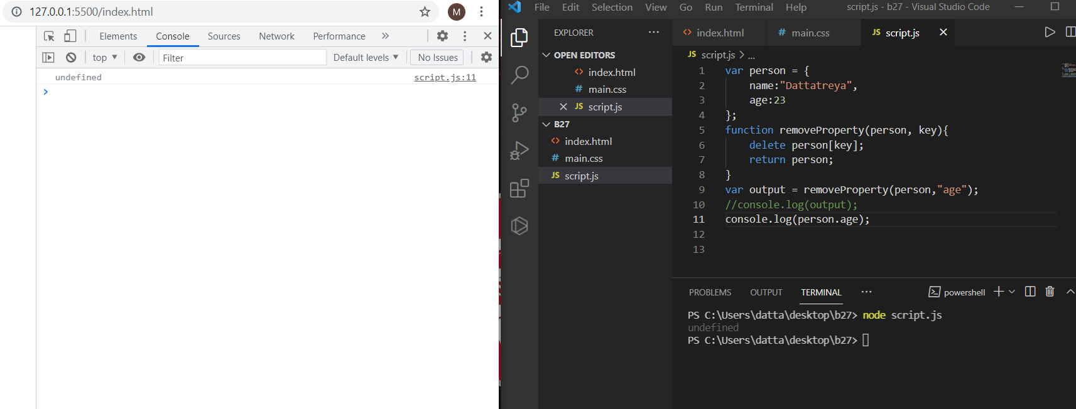

**24. Write a function called “addProperty”.**

**Given an object and a key, “addProperty” adds a new property on the given object with a value of true.**

**Input:addProperty(obj, “mykey”);**

**Output:{mykey: true}**

**var obj = {**

**mykey: "value"**

**};**

**function addProperty(obj, key){**

**obj[key] = true;**

**return obj;**

**}**

**console.log(addProperty(obj,"mykey"));**

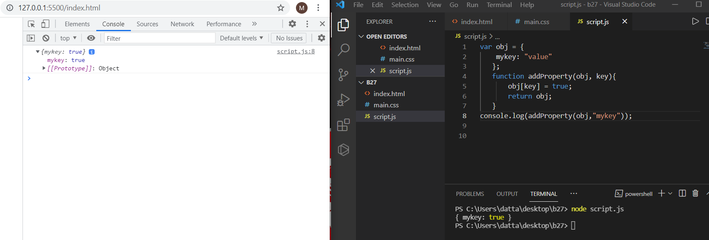

**25. Return an array, where the first element is the count of positives numbers and the second element is sum of negative numbers.**

**#with the including of zero**

**var arr = [-5, 10, -3, 12, -9, 5, 90, 0, 1];**

**var ar2 = function countPositivesSumNegatives(arr=[]) {**

**const arr1= arr.reduce((acc,val) => {**

**let [count,sum] = acc;**

**if(val >= 0){**

**count++;**

**}else if(val < 0){**

**sum += val;**

**}**

**return [count, sum];**

**},[0, 0]);**

**return arr1;**

**};**

**console.log(ar2(arr));**

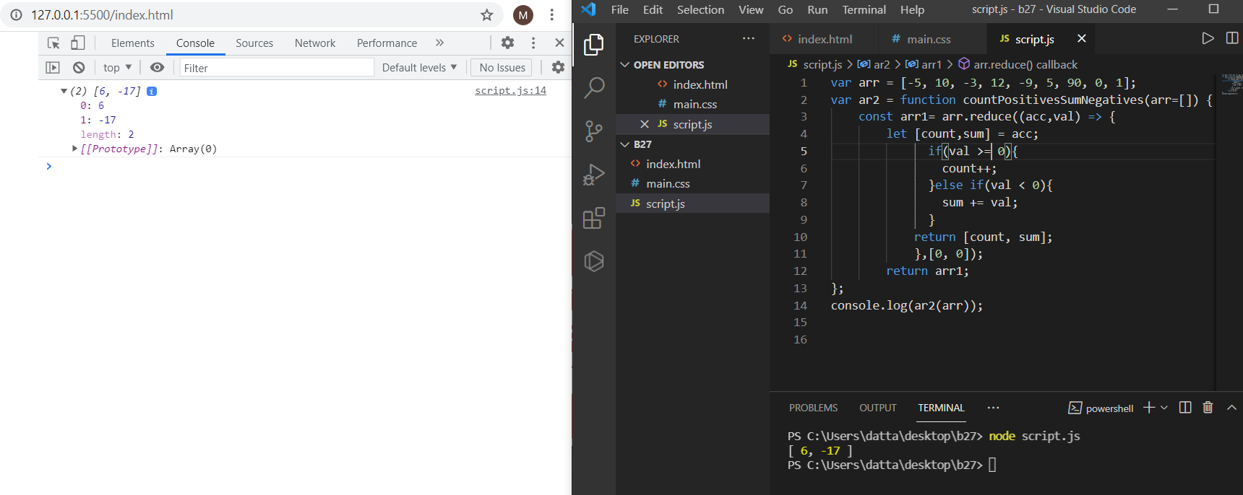

**var ar2 = function countPositivesSumNegatives(arr=[]) {**

**const arr1= arr.reduce((acc,val) => {**

**let [count,sum] = acc;**

**if(val > 0){**

**count++;**

**}else if(val < 0){**

**sum += val;**

**}**

**return [count, sum];**

**},[0, 0]);**

**return arr1;**

**};**

**console.log(ar2(arr));**

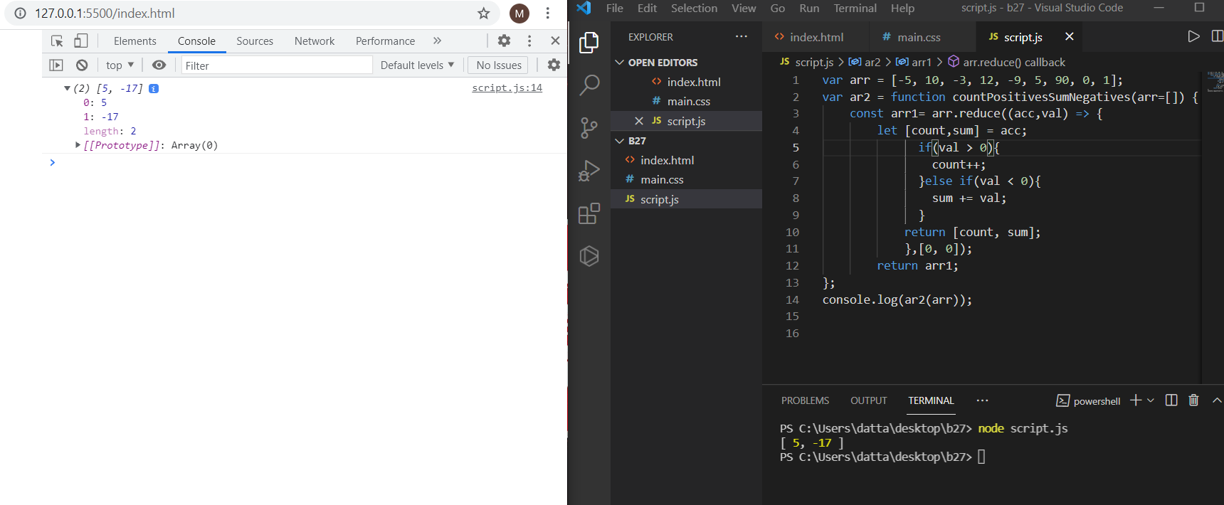

**26. Create a function that receives an array of numbers and returns an array containing only the positive numbers**

**function getPositives(ar)**

**{**

**var ar2 = [];**

**for(var i = 0; i < ar.length; i++)**

**{**

**var el = ar[i];**

**if (el >= 0)**

**{**

**ar2.push(el);**

**}**

**}**

**return ar2;**

**}**

**var ar = [-5, 10, -3, 12, -9, 5, 90, 0, 1];**

**var ar2 = getPositives(ar);**

**console.log(ar2);**

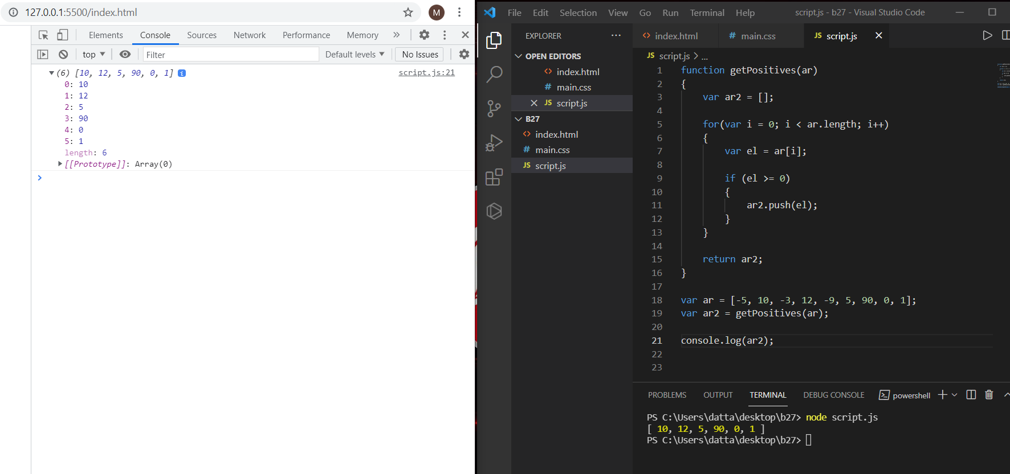

**27. Write a function `powersOfTwo` which will return list of all powers of 2 from 0 to n (where n is an exponent).**

**Input:**

**powersOfTwo(0)**

**powersOfTwo(1)**

**powersOfTwo(2)**

**Output:**

**1**

**1,2**

**1,2,4**

**function powersOfTwo(n){**

**var res = [];**

**for (let i=0; i<=n; i++){**

**res.push(2**i);**

**}**

**return res;**

**}**

**console.log(powersOfTwo(0));**

**console.log(powersOfTwo(1));**

**console.log(powersOfTwo(2));**

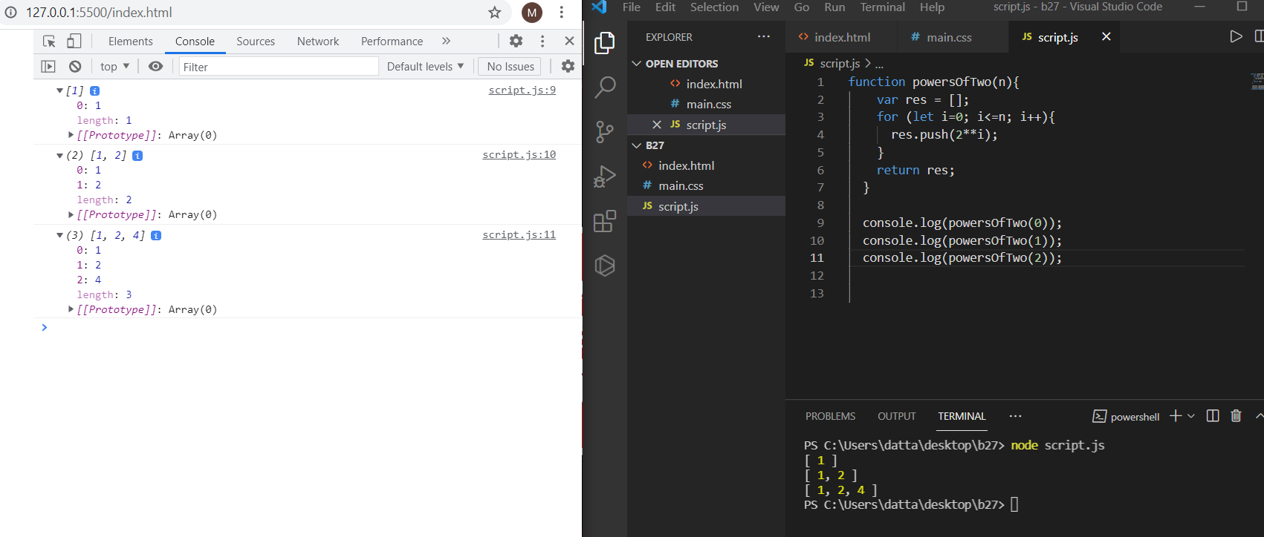

**28. Find the maximum number in an array of numbers**

**function findMax(ar)**

**{**

**var max = ar[0];**

**for(var i = 0; i < ar.length; i++)**

**{**

**if (ar[i] > max)**

**{**

**max = ar[i];**

**}**

**}**

**return max;**

**}**

**var ar = [-5, 10, -3, 12, -9, 5, 90, 0, 1];**

**var max = findMax(ar);**

**console.log("Max: ", max);**

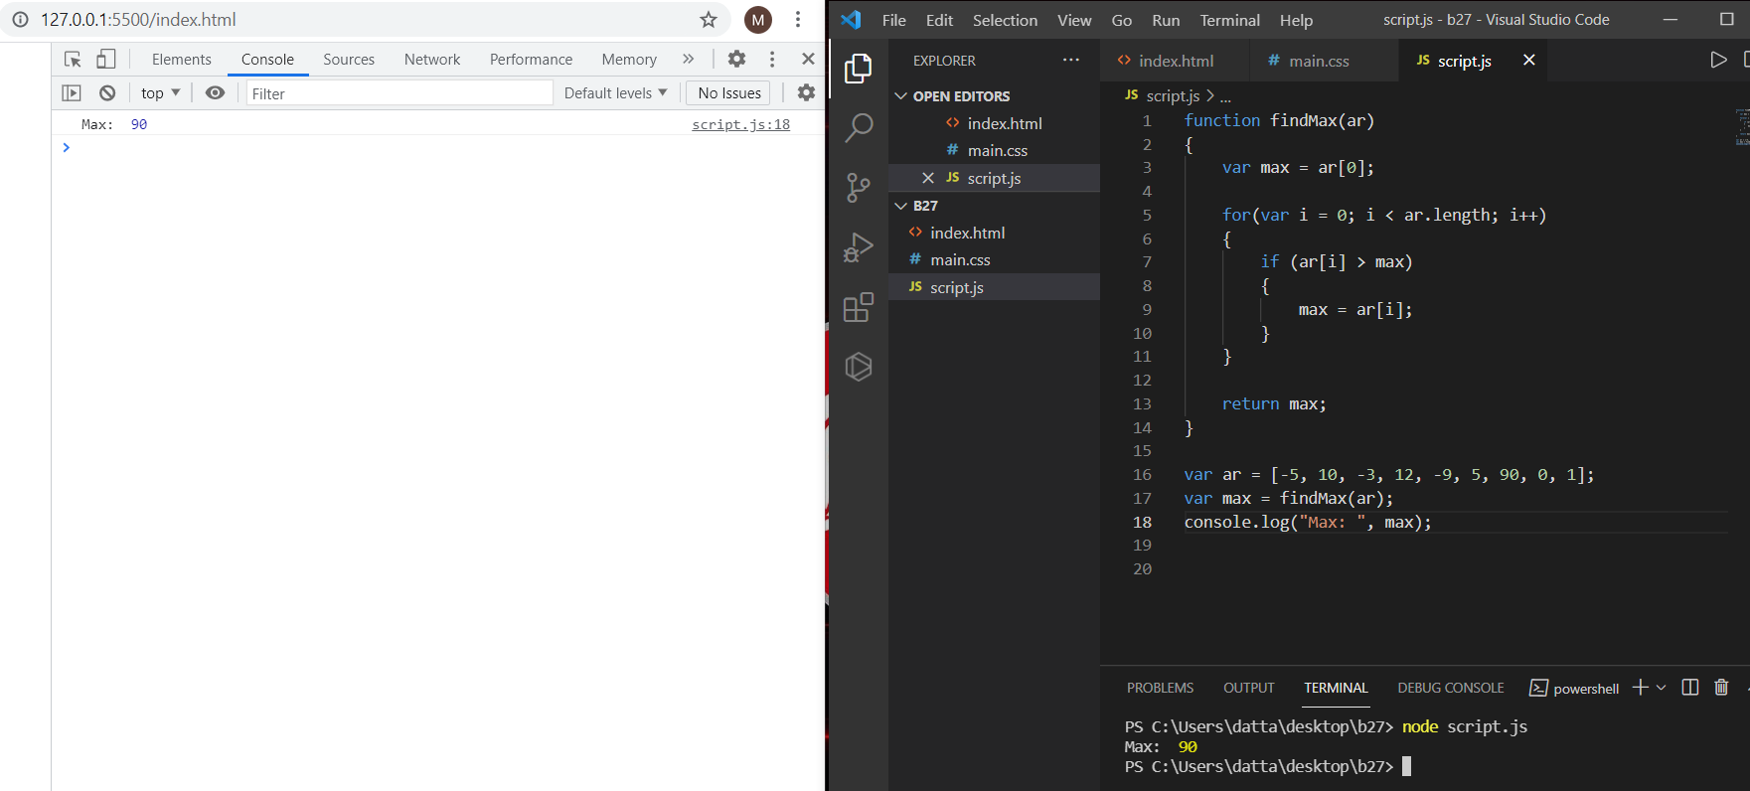

**29. Print the first 100 prime numbers**

**printPrimes(100);**

**// Function prints the first nPrimes numbers**

**function printPrimes(nPrimes)**

**{**

**var n = 0;**

**var i = 2;**

**while(n < nPrimes)**

**{**

**if (isPrime(i))**

**{**

**console.log(n, " --> ", i);**

**n++;**

**}**

**i++;**

**}**

**}**

**// Returns true if a number is prime**

**function isPrime(n)**

**{**

**if (n < 2)**

**return false;**

**if (n == 2)**

**return true;**

**var maxDiv = Math.sqrt(n);**

**for(var i = 2; i <= maxDiv; i++)**

**{**

**if (n % i === 0)**

**{**

**return false;**

**}**

**}**

**return true;**

**}**

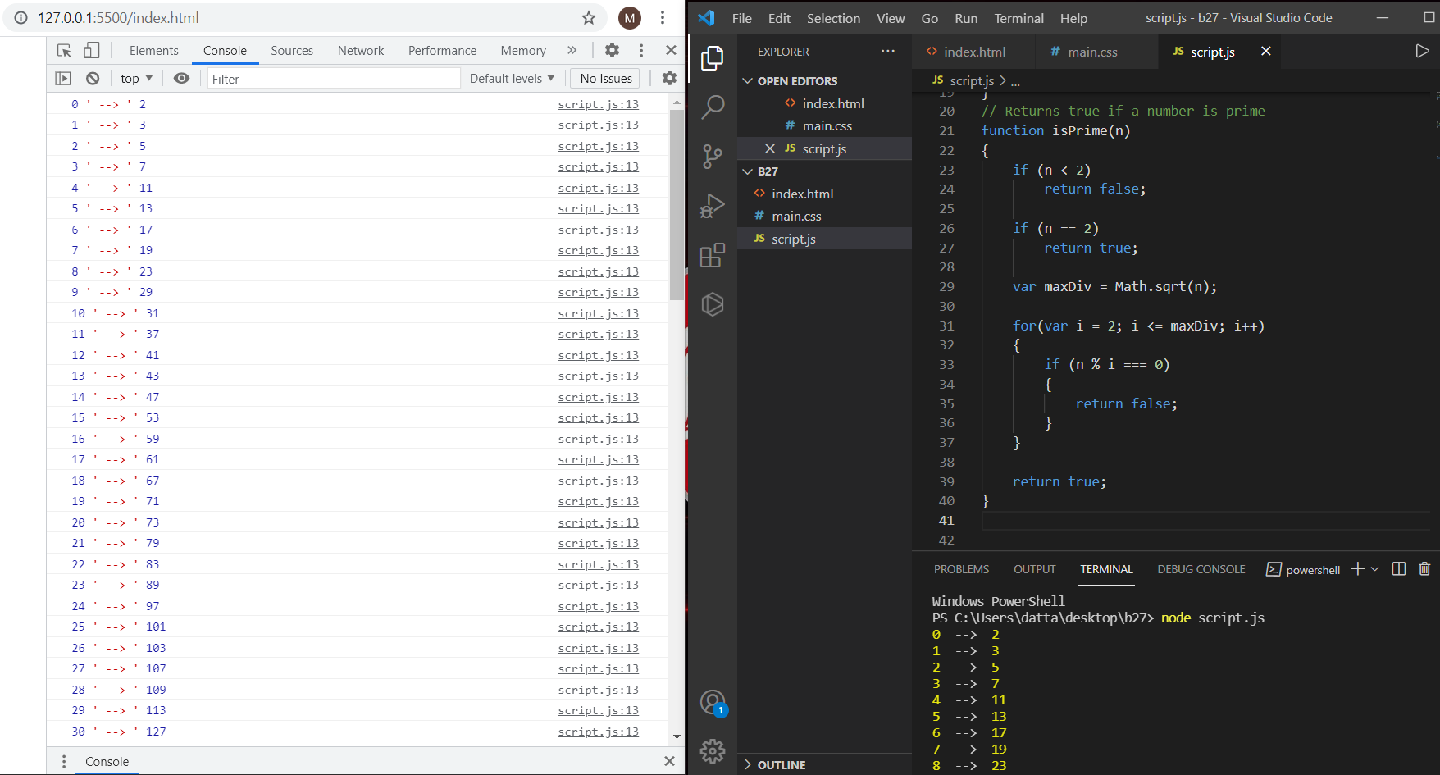

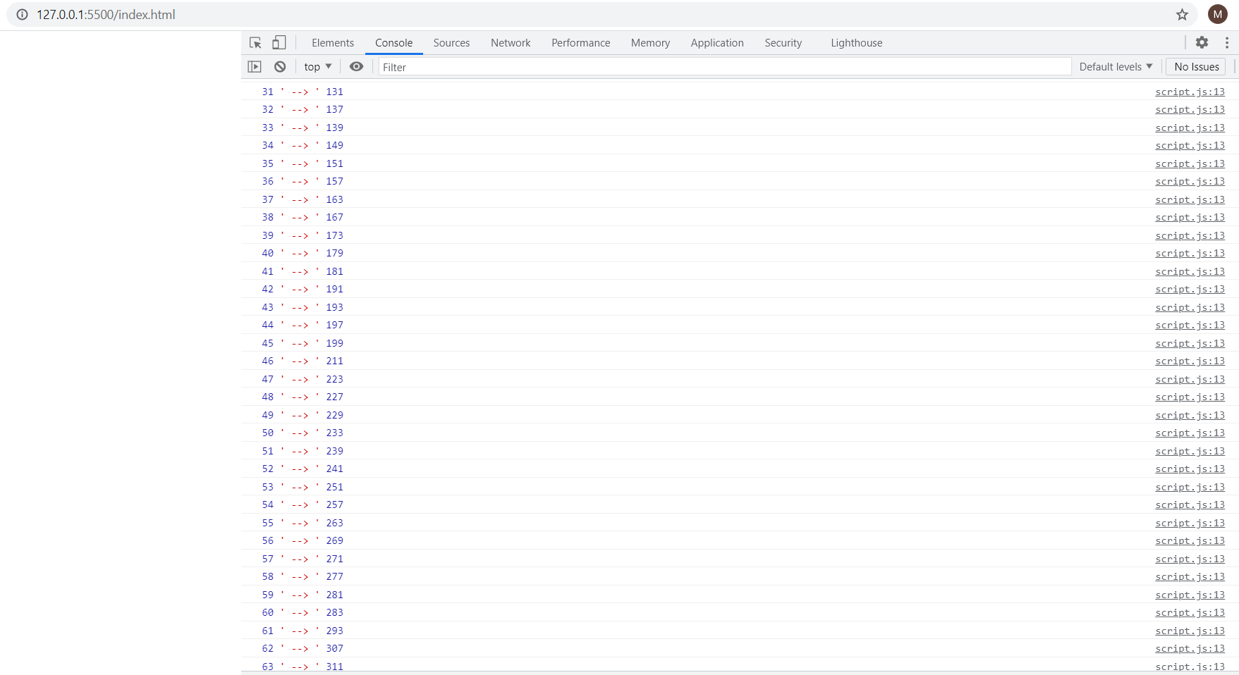

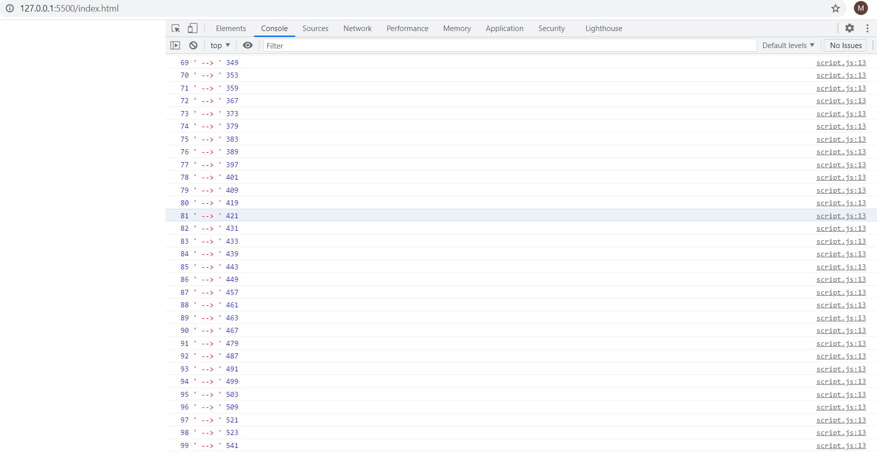

**30. Create a function that will return in an array the first “nPrimes” prime numbers greater than a particular number “startAt”**

**console.log(getPrimes(10, 100));**

**function getPrimes(nPrimes, startAt)**

**{**

**var ar = [];**

**var i = startAt;**

**while(ar.length < nPrimes)**

**{**

**if (isPrime(i))**

**{**

**ar.push(i);**

**}**

**i++;**

**}**

**return ar;**

**}**

**// Returns true if a number is prime**

**function isPrime(n)**

**{**

**if (n < 2)**

**return false;**

**if (n == 2)**

**return true;**

**var maxDiv = Math.sqrt(n);**

**for(var i = 2; i <= maxDiv; i++)**

**{**

**if (n % i === 0)**

**{**

**return false;**

**}**

**}**

**return true;**

**}**

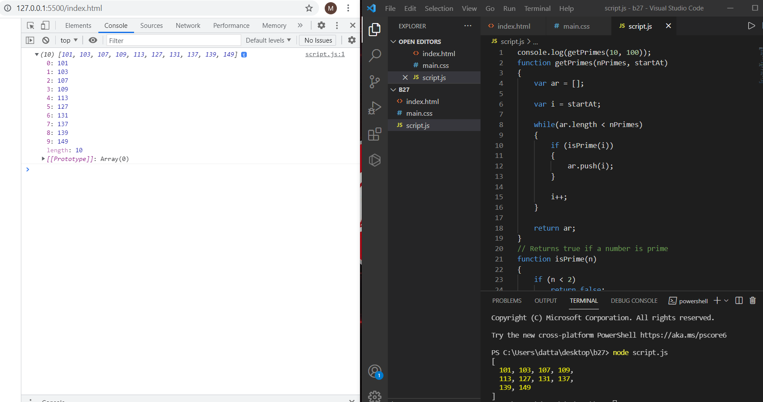

**31. Reverse a string**

**var s = reverseString("JavaScript");**

**console.log(s);**

**function reverseString(s)**

**{**

**// Step 1. Use the split() method to return a new array**

**var splitString = s.split("");**

**// Step 2. Use the reverse() method to reverse the new created array**

**var reverseArray = splitString.reverse();**

**// Step 3. Use the join() method to join all elements of the array into a string**

**var joinArray = reverseArray.join("");**

**//Step 4. Return the reversed string**

**return joinArray;**

**}**

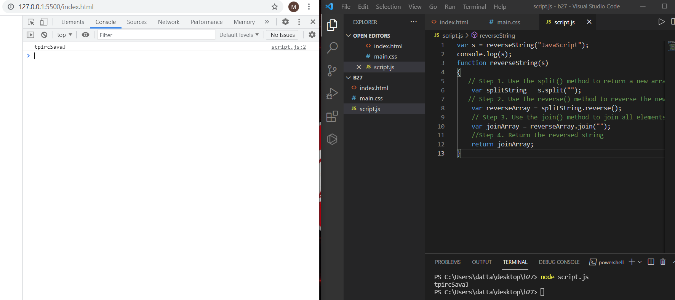

**32. Create a function that will merge two arrays and return the result as a new array**

**var ar1 = [1, 2, 3];**

**var ar2 = [4, 5, 6];**

**var ar = mergeArrays(ar1, ar2);**

**console.log(ar);**

**function mergeArrays(ar1, ar2)**

**{**

**var result = [];**

**//this will add the first array to the result array**

**for(let el of ar1)**

**{**

**result.push(el);**

**}**

**//Some piece of code goes here**

**return result.concat(ar2);**

**}**

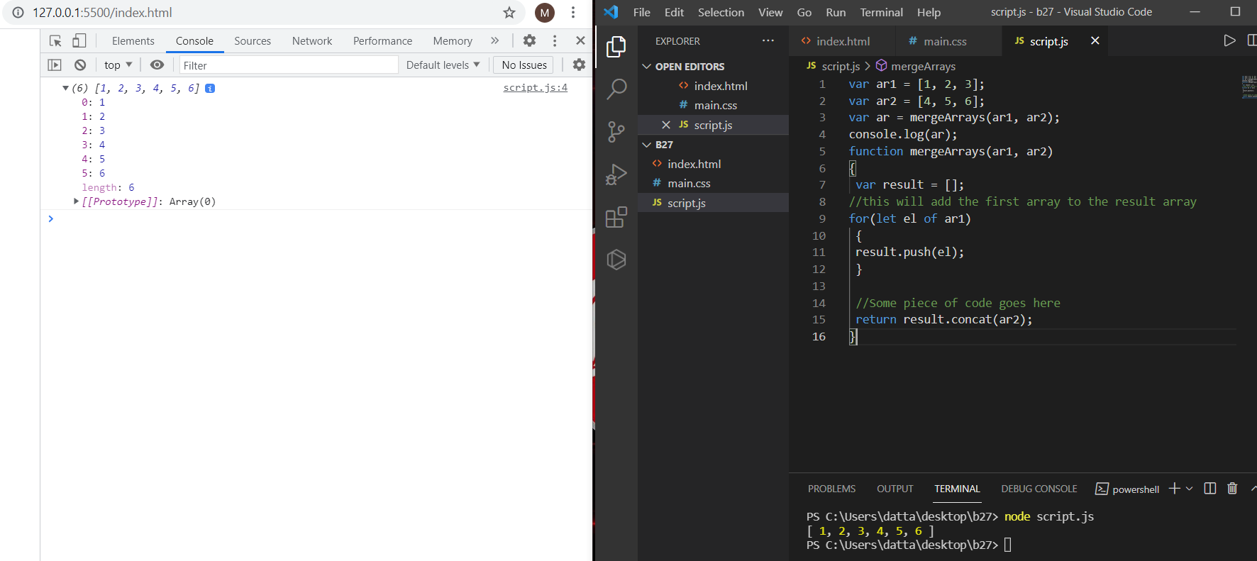

**33. Calculate the sum of numbers received in a comma delimited string**

**// Calculate the sum of numbers received in a comma delimited string**

**// calling the function and return the value**

**console.log(sumCSV("1.5, 2.3, 3.1, 4, 5.5, 6, 7, 8, 9, 10.9"));**

**function sumCSV(s)**

**{**

**//creating one variable with for the array and splitting them**

**var arrayNums = s.split(",");**

**// defining the sum value to zero**

**var sum = 0;**

**// Iterating over the array after splitting the string array**

**for(let i=0;i<arrayNums.length;i++){**

**// for every iteartion adding the value to the sum after completion we are returing it finally**

**sum+=parseFloat(arrayNums[i]);**

**}**

**return sum;**

**}**

